

**LAB ASSIGNMENT 2**

**SUBMITTED BY:** Kulsoom Khurshid

**REGISTRATION #:** SP20-BCS-044

**COURSE:** Operating System

**SUBMITTED TO:** MA’AM ZAHIDA WALIYAT

**Question no1:**

**Write the code for messages sending and receiving over shared memory**

**Solution:**

**SENDER**

PROGRAM:

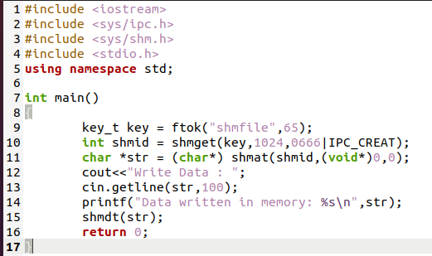

COMMANDS AND OUTPUT:

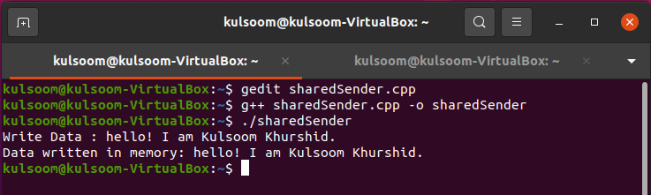

**RECEIVER**

PROGRAM:

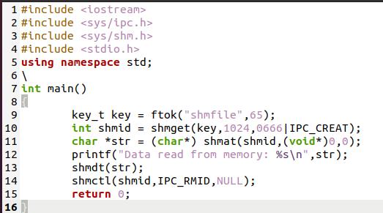

COMMANDS AND OUTPUT:

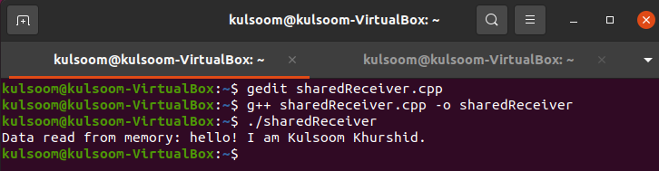

**Question no2:**

**Write the code for messages sending and receiving through message passing**

**Solution:**

**SENDER**

PROGRAM:

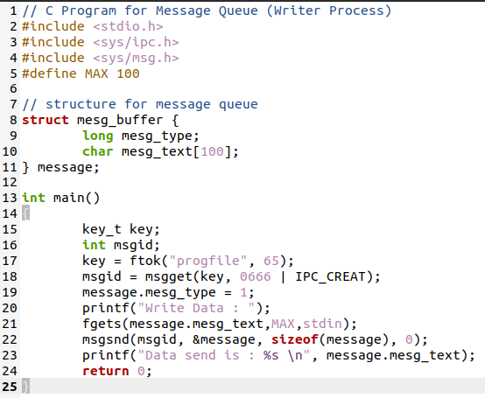

OUTPUT AND COMMANDS:

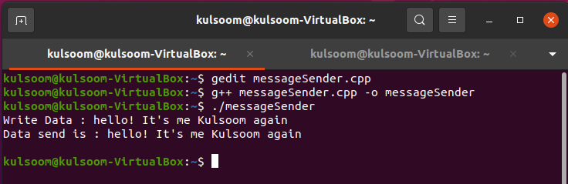

**RECEIVER**

PROGRAM:

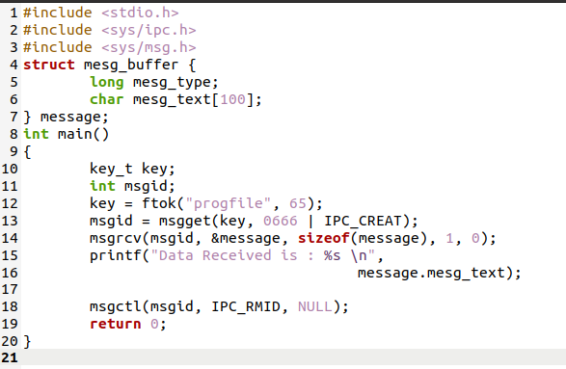

OUTPUT AND COMMANDS:

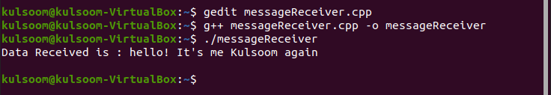

**Question no3:**

**Write the code for merge sort**

**Solution:**

PROGRAM:

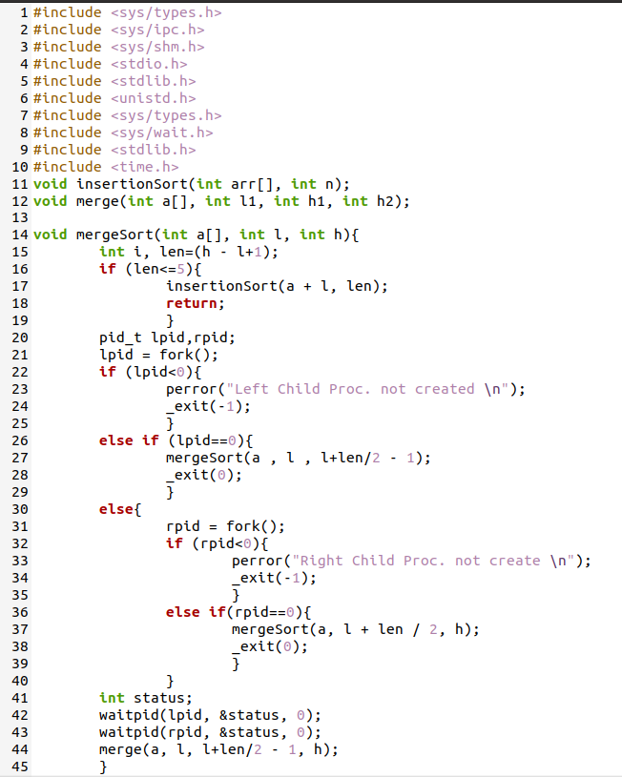

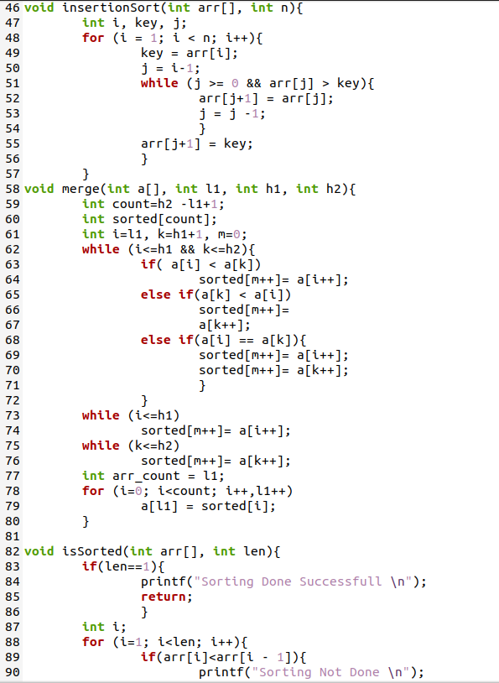

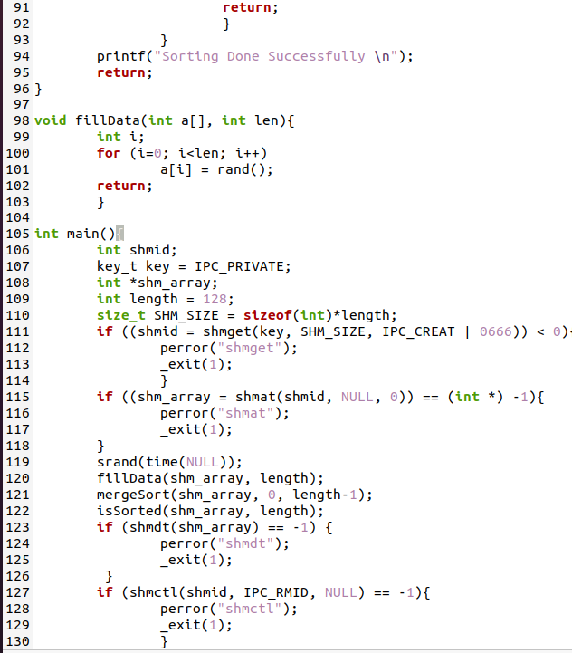

OUTPUT AND COMMANDS:

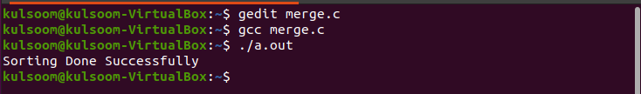

**Question no4:**

**Write the code for chat application using message queue**

**Solution:**

**CLIENT**

PROGRAM:

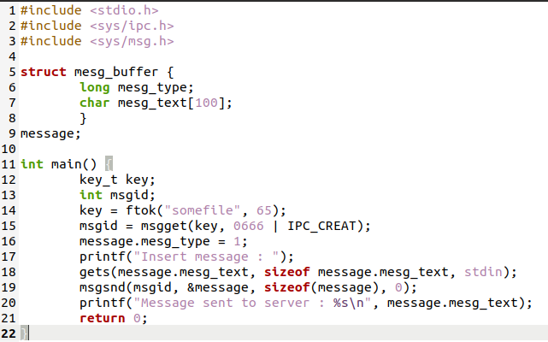

OUTPUT:

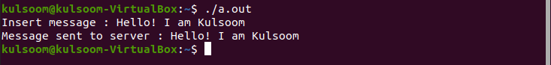

**SERVER**

PROGRAM:

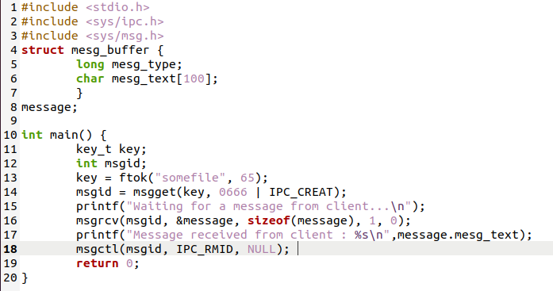

OUTPUT:

